DEMAND PAGING:
- Demand paging is the process of loading the pages only when they are demanded by the process during execution. Pages that are never accessed are thus never loaded into physical memory.
- A demand-paging system is similar to a paging system with swapping where processes reside in secondary memory
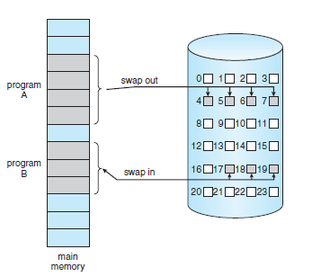
- When we want to execute a process, we swap it into memory. Rather than swapping the entire process into memory we use a lazy swapper that never swaps a page into memory unless that page will be needed.
- Lazy swapper is termed to as pager in demand paging.
- When a process is to be swapped in, the pager guesses which pages will be used before the process is swapped out again. Instead of swapping in a whole process, the pager brings only those pages into memory.
- Os need the hardware support to distinguish between the pages that are in memory and the pages that are on the disk. The valid–invalid bit scheme can be used for this purpose.
- If the bit is set to “valid,” the associated page is both legal and in memory.
- If the bit is set to “invalid,” the page either is not valid or is valid but is currently on the disk.
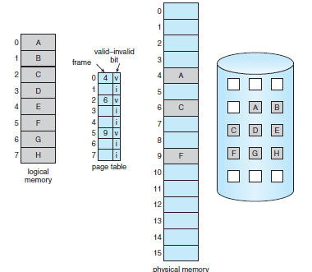

- PAGE FAULT: If the process tries to access a page that was not brought into memory, then it is called as a page fault. Access to a page marked invalid causes a page fault.
- The paging hardware, will notice that the invalid bit is set, causing a trap to the operating system.
- PROCEDURE FOR HANDLING THE PAGE FAULT:
1. Check an internal table (usually kept with the process control block) for this process to determine whether the reference was a valid or an invalid memory access.
2. If the reference was invalid, we terminate the process. If it was valid but we have not yet brought in that page, we now page it in.
3. Find a free frame
4. Schedule a disk operation to read the desired page into the newly allocated frame.
5. When the disk read is complete, we modify the internal table kept with the process and the page table to indicate that the page is now in memory.
6. Restart the instruction that was interrupted by the trap. The process can now access the page as though it had always been in memory.
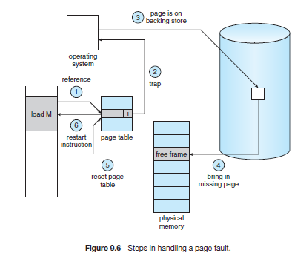
- PURE DEMANDPAGING: The process of executing a program with no pages in main memory is called as pure demand paging. This never brings a page into memory until it is required.
- The hardware to support demand paging is the same as the hardware for paging and swapping:
- • Page table. This table has the ability to mark an entry invalid through a valid–invalid bit or a special value of protection bits.
- • Secondary memory. This memory holds those pages that are not present in main memory. The secondary memory is usually a high-speed disk. It is known as the swap device, and the section of disk used for this purpose is known as swap space.
PERFORMANCE OF DEMAND PAGING:
- Demand paging can affect the performance of a computer system.
- The effective access time for a demand-paged memory is given by
    - effective access time = (1 − p) × ma + p × page fault time.
- The memory-access time, denoted ma, ranges from 10 to 200 nanoseconds.
- If there is no page fault then the effective access time is equal to the memory access time.
- If a page fault occurs, we must first read the relevant page from disk and then access the
desired word.
- There are three major components of the page-fault service time:
1. Service the page-fault interrupt.
2. Read in the page.
3. Restart the process

- With an average page-fault service time of 8 milliseconds and a memory access time of 200 nanoseconds, the effective access time in nanoseconds is
Effective access time = (1 − p) × (200) + p (8 milliseconds)
= (1 − p) × 200 + p × 8,000,000
= 200 + 7,999,800 × p.
- Effective access time is directly proportional to the page-fault rate.

